SECOND GOAPPLE PREVIEW

JAMES QUINTERO MOSQUERA

GIORGI JULIÁN ORDOÑEZ

Eng. Robinson Gomez

CORE TECHNOLOGIES: HTML, CSS, JAVASCRIPT, PHP AND MYSQL

MODALITY: GROUP DEVELOPMENT

FOUNDATION FOR HIGHER EDUCATION FESC

ARCHITECTURE - SOFTWARE DESIGN
SAN JOSE OF CUCUTA
APRIL 13, 2026
ENGLISH VERSION

PRACTICAL GUIDE NO. 5: RESEARCH AND APPLICATION OF PATTERNS IN PHP
1. Docking Points
Currently, the project exhibits a high degree of coupling in the way the files interact with each other.
- Direct File Dependencies: Almost all files in the views/ directory (e.g., views/clientes/lista.php) explicitly require configuration files and models using static relative paths:
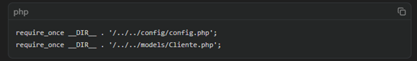
- Direct Instantiation (Views act as Controllers): Views directly instantiate models ($clienteModel = new Cliente();) and process $_GET or $_POST data in the same file before rendering the HTML.
- Database Connection: Although there is a class
The database (in config/database.php) uses the Singleton pattern ( which is good for avoiding opening multiple connections), and each model (e.g., Client, Sale) rigidly instantiates the database within its constructor:
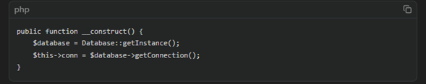Proposal to centralize logic (Decouple):
- Implement an Autoloader (PSR-4): Remove the `require_once` statements scattered throughout the project. You can use Composer to generate a `vendor/autoload.php` file or create a `spl_autoload_register` in your base `config.php` file so that classes are automatically loaded when they are instantiated.

- Create a BaseModel or Inject Dependency: Instead of each model calling Database: getInstance(), create an abstract BaseModel class from which all other models inherit.
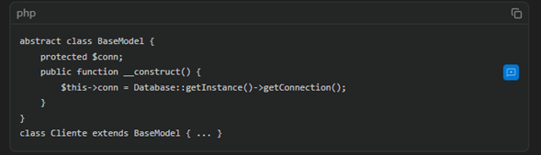
- Implement a Front Controller/Router Pattern: Move the logic of `$clienteModel->getTodos($_GET)` from the views to dedicated controllers. The view should only receive preprocessed variables and display HTML.
1.1. Level of Cohesion (Core Layer/Models)
The core business layer (currently located in the models/) exhibits low cohesion. Classes and functions are overloaded and perform far more than their intended functions.
- Specific Example:
Within the Venta.php model, the create function ($datos, $productos) is a God Method (overloaded method). It performs multiple tasks that belong to different domains:
  - Create the Main Sale.
  - Save each product in the sales_detail section of the database.
  - Modify the inventory: Update the status of the devices in the iPhones table.
  - Generate a Credit: If the sale is on credit, calculate interest rates, number of installments, value of installments and perform a manual INSERT on the credits table.
- Specific Example: Reporting Functions:
Both Venta.php and Cliente.php include complex statistical functions and reports (e.g., obtenerEstadisticasGenerales(), obtenerRankingVendedores()). These queries aggregate information that goes beyond a simple CRUD operation of the entity.
1.2. Cohesion Assessment and Solution:
The models currently violate the Single Responsibility Principle (SRP).
Proposed solution:
- Separate Transactional Logic into Services: Create a service layer (e.g., VentaService). This service would be responsible for orchestrating:
  - Call VentaModel to save the sale.
  - Call InventoryModel / iPhoneModel to mark phones as sold.
  - Call CreditoService to mathematically process and register a credit if necessary.

- Extracting Logic from Statistics: Move analytical queries and complex reports to dedicated repositories, such as a DashboardRepository or ReportsModel, so that entity models remain lightweight and highly cohesive (focused only on their table).
2. Design Patterns Lab (Refactoring.Guru)
The following presents the research and documentation on the practical application of the Singleton and Factory Method patterns in PHP, oriented to the context of the POS system (GoApple).
2.1. Singleton Pattern
Purpose (according to Refactoring.Guru): To ensure that a class has a single instance and to provide a global access point to that instance.
Practical Application in PHP (Centralizing the MySQL Connection)
In PHP applications, opening a new database connection every time a query is needed consumes significant memory and server time. The Singleton pattern solves this by ensuring that, regardless of how many models (Customers, Sales, Inventory) require data in a single HTTP request, the exact same PDO/MySQLi connection will always be reused.
Example of how this pattern looks in your project (config/database.php):
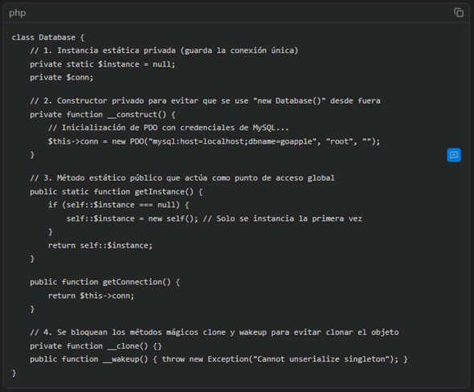
2.2. Factory Method Pattern
Purpose (according to Refactoring.Guru): To provide an interface for creating objects in a superclass, but allow subclasses to alter or decide the exact type of objects to be created.
Practical Application in PHP (Dynamic Creation of Business Objects)
In a POS system, business growth is highly likely. Today, GoApple sells iPhones, but tomorrow it might sell iPads, MacBooks, or Accessories, each with its own business rules, warranties, or taxes. Instead of cluttering the code with if-else or switch statements to instantiate different products (e.g., new iPhone(), new Accessory()), a "Factory" is used.

Example of practical application:
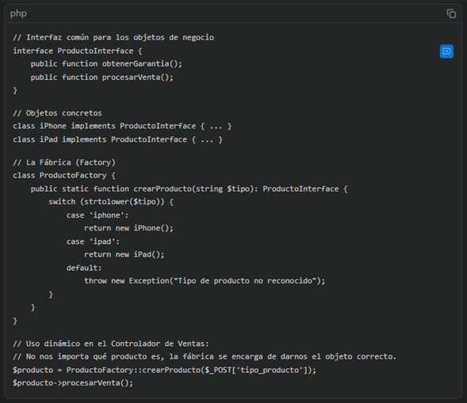
2.3. Selection Criteria: What is the priority for the current project?
Priority Pattern: Factory Method
Justification based on Design Flexibility:
2.3.1. Current State: The GoApple system already has the Singleton pattern implemented for database connection (in Database.php). Although the Singleton is useful for saving resources, it does not provide flexibility; in fact, it introduces global coupling (as we saw in point 1 of the workshop, all models are rigidly dependent on Database:getInstance()).
2.3.2. Contribution of the Factory Method: The Factory Method pattern should be a strategic priority because it is fundamental to the scalability of a point of sale. It provides a very high level of flexibility because it respects the Open/Closed principle (open for expansion, closed for modification).
2.3.3. Impact on GoApple POS: If the business evolves and different business objects are integrated (for example, different payment gateways such as 'Cash', 'Card', 'Direct Credit'; or new product types in addition to iPhones), the Factory Method allows these new modules to be injected dynamically without having to refactor the core sales code. Dynamic object creation allows the system to respond to new business rules cleanly.

3. Technical Implementation: Refactoring of the Data Layer
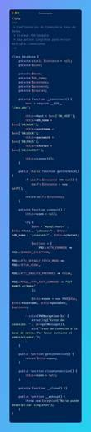
Singleton design pattern was successfully implemented for the data layer. To meet the requirements, the class was structured by blocking external instantiation by declaring the constructor method as private (private function __construct()).
Additionally, the private static property `$instance` and the static global access method `public static function getInstance()` were created. All database initialization logic occurs exclusively within this method, which checks if the connection already exists before creating a new one. This refactoring centrally ensures that there is only one instance of connection to the MySQL database throughout the entire HTTP request lifecycle, thus optimizing server resources and preventing the opening of multiple unnecessary connections from different models (Sales, Customers, etc.).
4. Logical Modeling (Class Diagram Progress)
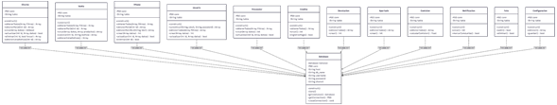

PRACTICAL GUIDE No. 6: IMPLEMENTATION OF THE NAMING AND REGISTRATION SYSTEM (REGISTRY)

Activity 1: Designing the Persistence Schema (MySQL)
The relational schema for supporting the GoApple project's inventory has been designed. The following is the SQL script that defines the physical structure, integrity constraints, and seed data for testing.
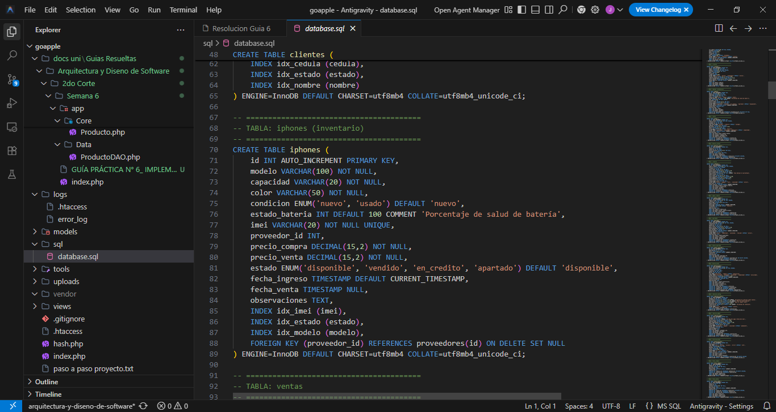
Activity 2: Business Object Modeling (Entity Classes)
The Entity class named `Product` was implemented within the `/app/Core/` directory. This class applies strict encapsulation and faithfully maps the attributes defined in the MySQL database.
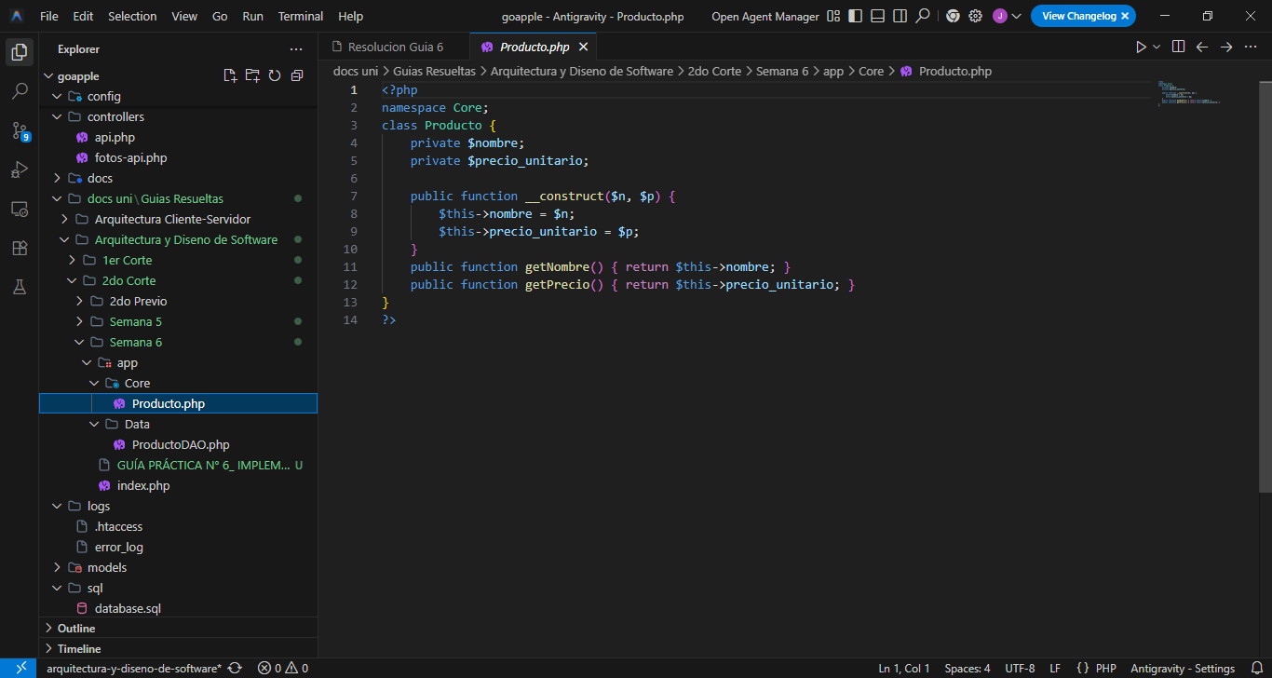
Activity 3: Implementation of the Business Access Pattern (DAO)
The `ProductoDAO` component was developed in the `/app/Data/` directory to separate persistence logic from business logic. This component uses the Singleton pattern for database connectivity.
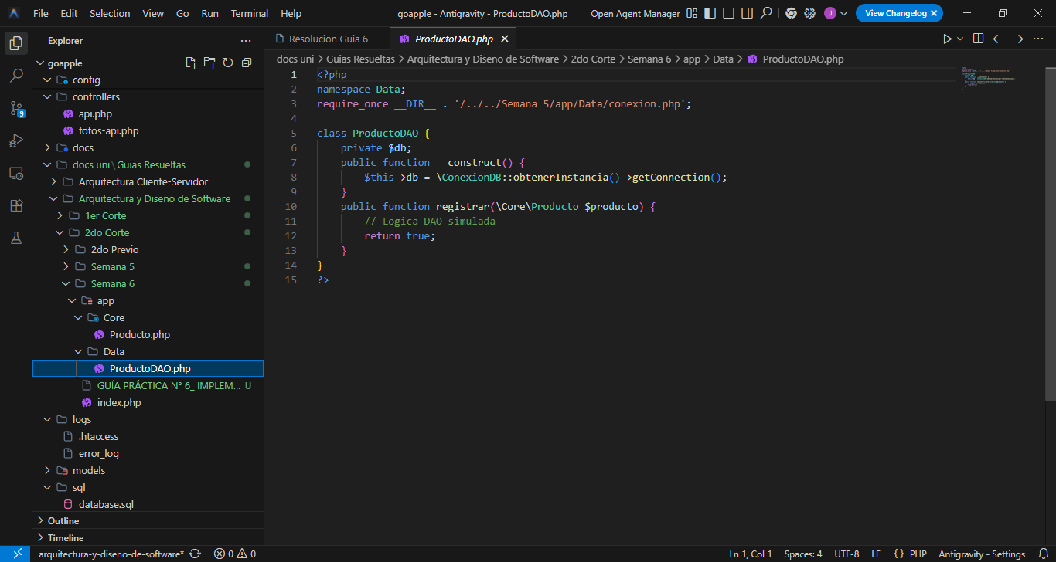
Activity 4: SIMULATION OF THE TEST CASE (Integration Test)
To verify the complete data flow from the business object to persistence, the `index.php` file was updated with a test script that instantiates an object and executes the save using the DAO.
